

NATURAL LANGUAGE PROCESSING PROJECT

**Title: ChatOps Assistant with NLP for Kubernetes (llama, T5-Base fine-tuned)**

**Team:**

Tarun.E – 22BCE2505 Slot: D1+TD1

Github Link:

<https://github.com/TarunCore/nlp-to-k8s-command>

ChatOps Assistant with NLP for Kubernetes

Tarun Ea,∗

*aVellore Institute of Technology, Vellore, India*

# Abstract

Kubernetes has become the standard for container orchestration, but its command-line in- terface (kubectl) includes a vast array of commands and options that can be daunting for practitioners. This paper explores the training of a custom language model, **Llama-3.1- 8B-Instruct**, to act as a Kubernetes assistant by translating natural language instruc- tions into correct kubectl commands (e.g., “create nginx deployment” → kubectl rollout restart deployment frontend). We fine-tune a 8-billion-parameter LLaMA-based model on a specialized corpus of **35k pairs** of human-like instructions [1] and Kubernetes CLI commands to enable natural language interface for cloud operations. We discuss how our approach leverages sequence-to-sequence learning and compare it with other large lan- guage models (LLMs) and code-focused models like T5, CodeBERT, and CodeT5. In our experiments, the fine-tuned model demonstrates promising accuracy in generating valid commands and generalizing to unseen tasks, reducing the need for Kubernetes expertise to perform routine operations. This work contributes to bridging NLP and DevOps, illus- trating that an instruct-tuned LLM can simplify cluster management by understanding user intent and producing correct, executable commands.

*Keywords:* Natural Language Interface, Large Language Models,

Sequence-to-Sequence, Llama, Code Generation, Kubernetes

# Introduction

Kubernetes is a powerful yet complex system for automating deployment and manage- ment of containerized applications. Administrators and developers interact with Kuber- netes primarily through kubectl, a command-line tool that exposes hundreds of commands

∗Corresponding author

*Email address:* [tarun.2022@vitstudent.ac.in](mailto:tarun.2022@vitstudent.ac.in) (Tarun E)

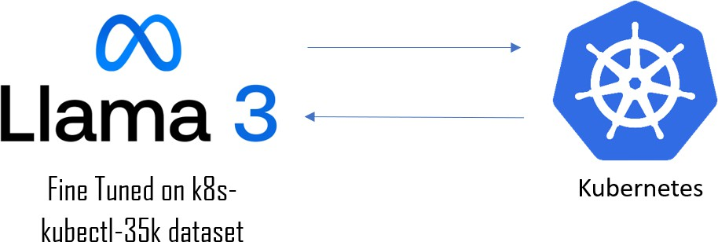

Figure 1: Architecture

5 and flags. Mastering these commands requires significant expertise, as even common tasks demand precise syntax and knowledge of resource types. Natural language interfaces for developer operations allow users to issue instructions in everyday language and have an intelligent system translate them into the appropriate technical commands. Our work focuses on such an interface for Kubernetes: Given a user query or intent in English,

10 generate the correct kubectl command to execute that intent.

Recent advances in large-scale language models have made this vision feasible. LLms like OpenAI’s GPT series and Meta’s LLaMA have demonstrated an ability to gener- ate code and CLI instructions from plain language descriptions [2]. This highlights how domain-specific training dramatically improves performance. Meta’s LLaMA models fur-

15 ther show that even smaller-scale open models can reach state-of-the-art results when trained on enough data [3] . Specifically, **LLaMA’s 13B model** outperforms the much larger **175B GPT-3** on many benchmarks [3] , suggesting that with proper fine-tuning, moderately sized models can excel in specialized tasks. We therefore investigate fine- tuning an open-source LLM (based on LLaMA architecture) for the specialized task of

20 Kubernetes command generation. We position our approach in the context of sequence- to-sequence models and code-focused transformers. **Sequence-to-sequence** architec- tures (like the encoder-decoder Transformer in T5) are well-suited for translation tasks – not only between human languages but also from instructions to commands.**Google’s T5** (“Text-to-Text Transfer Transformer”) [4] demonstrated the power of treating every

25 NLP task as text-to-text; after massive pre-training, T5 achieved state-of-the-art on a wide range of language tasks by simply varying the input/output text formats [4]. This

text-to-text framework can naturally encompass “NL → CLI command” translation. We also consider models pre-trained specifically on code. **CodeBERT**, for example, is a bimodal Transformer pre-trained on natural language and programming language data

30 [5]. While CodeBERT is primarily an encoder (good for code search or classification tasks), encoder-decoder models like **CodeT5** combine the strengths of T5 with code- centric training to support both understanding and generation of code [6]. These models learn representations of programming syntax and semantics that could be very useful for mapping natural language to a formal command syntax.

35 Early efforts like **NL2Bash** [7] laid the groundwork by creating datasets of natural language to shell command pairs. However, Kubernetes manifests and commands intro- duce domain-specific vocabulary and constraints. Off-the-shelf LLMs might not reliably produce valid kubectl invocations, as they lack focused knowledge of this domain. This motivates our work to fine-tune an LLM on a targeted Kubernetes corpus. By training

40 on 35,000 (instruction, command) pairs curated for Kubernetes tasks, our Llama-3.1-8B- Instruct model [8] learns the syntax and patterns of kubectl commands along with the associations to user intents. We choose a smaller 8B parameter model to allow feasible training on available hardware, **hypothesizing that domain-specific data can com- pensate for model size to some extent** (a hypothesis supported by recent findings

45 that smaller specialized models can sometimes outperform larger general models on niche tasks [9]).

The salient contributions of the paper are,

1. **Domain-Specific Fine-Tuning of LLaMA-3.1-8B-Instruct:** We fine-tune an open-source LLaMA-3.1-8B-Instruct and T5-Base model on the ComponentSoft/k8s-

50 kubectl-35k [1] dataset to accurately translate natural language queries into exe- cutable k8s kubectl commands.

1. **Parameter-Efficient Adaptation via LoRA:** We employ Low-Rank Adaptation (LoRA) techniques to achieve efficient fine-tuning, significantly reducing computa- tional and memory requirements while maintaining high accuracy in Kubernetes

55 command generation, demonstrating the viability of parameter-efficient methods

for domain adaptation.

# Literature Survey

Natural Language to Command Translation: Early research on translating natural language to executable commands falls under semantic parsing and program synthesis.

60 A notable contribution in this area is **NL2Bash** by Lin et al. (2018), who constructed a corpus of 9,000 natural language descriptions matched with Bash shell commands [7]

. Their approach utilized a semantic parsing model to map English sentences to Bash syntax, representing one of the first attempts at an NL-to-CLI interface. The NL2Bash dataset was largely derived from web forums and expert annotation, and it revealed

65 that even relatively simple shell tasks could be difficult for sequence models due to the need for reasoning about filenames, pipes, flags. Subsequent improvements came from applying neural machine translation techniques. For example, Fu et al. (2021) employed a Transformer-based sequence-to-sequence model on the Bash translation task, significantly improving accuracy over **RNN-based** baselines [10].By 2022, Fu et al. introduced an

70 augmented dataset and workflow to synthetically expand training examples, achieving over 50% exact-match accuracy in translating English to Bash on their benchmarks [11]

- a substantial leap from earlier performance 13% exact match.

Another line of work focused on interpretability: Bharadwaj and Shevade (2021) pro- posed an explainable method using Abstract Syntax Trees (ASTs) for the NL → Bash

75 task [12]. By generating intermediate AST representations, their system made the trans- lation more transparent and allowed users to understand which parts of the command corresponded to which words. These efforts, summarized in **Table 1**, demonstrated the viability of natural language interfaces for systems operations but also highlighted limita- tions: small dataset sizes, limited generalization to unseen commands, and lack of context

80 about the system state.

5

|  |  |  |  |  |
| --- | --- | --- | --- | --- |
| **S. No.** | **Title & Reference** | **Methodology / Dataset** | **Key Findings / Contributions** | **Limitations / Gaps** |
| 1 | *NL2Bash: A Corpus and Semantic Parser for NL to Bash* – Lin et al., 2018 [7] | Collected 9k NL-command pairs; se- mantic parsing with seq2seq model for Bash CLI. Dataset from StackOverflow  + expert curation. | Released first large dataset for NL→Shell; demonstrated feasibil- ity of translating English to Bash  commands. | Limited coverage of commands; baseline accuracy was low (*<*30% exact match); struggled with complex multi-step com-  mands. |
| 2 | *Transformer-based Approach for NL2Bash* – Fu et al., 2021 [13] | Applied Transformer model (encoder- decoder) to NL2Bash using expanded training data (incl. synthetic examples). | Achieved substantial accuracy improve- ment (SOTA at the time, 50% ex- act match); showed effectiveness of data augmentation and modern NMT archi-  tecture. | Focused only on Bash; still errors on un- seen utilities or rare arguments; needed execution feedback to further improve. |
| 3 | *Explainable NL2Bash (AST-Based)* – Bharadwaj & Shevade, 2021 [12] | Used Abstract Syntax Tree intermediate representation for parsing NL to Bash. Model predicts AST nodes which are  then rendered as commands. | Improved interpretability of command generation; model’s decisions more transparent by aligning NL phrases to  parts of command syntax. | Slightly lower raw accuracy than pure neural approaches; limited to commands that can be represented by a known AST  grammar. |
| 4 | *NLC2CMD Competition* – Agarwal et al., 2021 [11] | Organized NeurIPS competition with a new dataset ( 10k) of NL to Bash tasks. Various teams tried seq2seq, retrieval, ensemble methods. | Established standard evaluation for NL→Command; introduced execution- based metrics and energy efficiency con- siderations. Winning models achieved  70% execution success via ensembling. | Focus on Bash only; some solutions relied on task-specific tricks; general- ization beyond competition data not proven. |
| 5 | *T5: Text-to-Text Transformer* – Raffel et al., 2020 [4] | Unified seq2seq architecture pre-trained on massive text corpus (“Colossal Clean Crawled Corpus”). Fine-tuned on di- verse NLP tasks by framing each as text→text. | Achieved SOTA on many NLP bench- marks; demonstrated flexibility of a sin- gle model on translation, QA, summa- rization, etc. Provided a paradigm for treating code generation as “text trans-  lation.” | Not specifically trained on code or CLI data; performance on code tasks im- proved only with further fine-tuning. Large model (11B for T5-11B) – resource-intensive. |

6

|  |  |  |  |  |
| --- | --- | --- | --- | --- |
| **S. No.** | **Title & Reference** | **Methodology / Dataset** | **Key Findings / Contributions** | **Limitations / Gaps** |
| 6 | *CodeBERT: Pre-trained NL-PL Model*  – Feng et al., 2020 [5] | Bi-modal Transformer (RoBERTa- based) trained on NL and source code data (GitHub) with MLM+RTD objec- tive. Used for code search, generation  via fine-tuning. | Learned joint embeddings for code and text; improved tasks like code search and doc generation. Enabled under- standing of both code syntax and seman-  tics. | Encoder-only architecture means it’s not inherently generative; requires pairing with a decoder for generation. Not fo- cused on CLI or YAML commands. |
| 7 | *CodeT5: Encoder-Decoder for Code* – Wang et al., 2021 [6] | Pre-trained T5 model on 8.5M func- tions in multiple languages plus com- ments. Introduced identifier-aware masking and dual-generation (code to  comment) tasks. | Achieved SOTA on code summarization and synthesis tasks; handles both under- standing and generation. Code-specific objectives enhanced performance. | Large model (220M–770M) but still smaller than GPT; may miss domain- specific tokens (e.g., K8s resource names) unless fine-tuned. |
| 8 | *CodeT5+: Open Code LLMs for Un- derstanding and Generation* – Wang et al., 2023 [14] | Unified seq2seq architecture with mod- ular encoder-decoder, trained on large- scale code datasets using mixed objec-  tives; supports models from 220M–16B. | Outperforms larger models in many code tasks; small models (*<*1B) can compete well with specialized objectives. | T5-Base scale models still underper- form on hard code tasks; lacks focus on CLI/IaC domains. |
| 9 | *KGen: Kubernetes Manifest Genera- tion* – Angi et al., 2025 [9] | Pipeline fine-tuning LLMs for K8s YAML creation. Used few-shot prompt analysis and fine-tuned models (e.g., LLaMA3-8B, Mixtral-8x7B) on in-  tent→manifest data. | Validated LLMs can generate correct K8s configs. Smaller MoE models with good examples outperformed larger gen- eral ones. | Focused on YAML configuration, not imperative commands. Pipeline is com- plex. Syntax correctness issues remain. |
| 10 | *Intent-Based Cloud Management (Ap- pleseed)* – Lin et al., 2023 [15] | Few-shot system for infrastructure au- tomation. Users express intents (e.g., network, cloud), and LLM generates ac-  tions or configs. | Multi-domain applicability; reduced burden on users needing deep techni- cal knowledge. Enabled intent-to-action  translation. | Still early-stage; performance varies across domains. Requires robust grounding and feedback mechanisms. |
| 11 | *Llama 2: Open Foundation and Fine- Tuned Chat Models* – Touvron et al., 2023 [16] | Introduced LLaMA 2 models (7B–70B) and fine-tuned chat variants using in- struction tuning + RLHF on web-scale  datasets. | Matched performance of closed models in helpfulness and safety; open-source and reproducible methodology for in-  struction tuning. | Still lags GPT-4 in complex tasks; vul- nerable to hallucinations; long-context reasoning is limited. |

7

|  |  |  |  |  |
| --- | --- | --- | --- | --- |
| **S. No.** | **Title & Reference** | **Methodology / Dataset** | **Key Findings / Contributions** | **Limitations / Gaps** |
| 12 | *Code Llama: Open Foundation Models for Code* – Rozière et al., 2023 [17] | Fine-tuned LLaMA 2 on curated code datasets (multi-language, Python- specialized, and instruction variants);  supports 16K context and infilling. | SOTA performance on HumanEval, MBPP, and MultiPL-E benchmarks; Python-specialized 7B outperforms gen-  eral 70B. | Limited performance in non-Python do- mains; does not guarantee secure or de- ployable code. |
| 13 | *Balancing Continuous Pre-Training and Instruction Fine-Tuning* – Jindal et al., 2024 [18] | Compared strategies for updating LLaMA 3 models while preserv- ing instruction-following; evaluated  1.5B–8B scale models. | Proposed compute-efficient training pipeline to retain instruction skills after updating base models. | Less effective for very small mod- els; assumes access to both base and instruction-tuned models. |
| 15 | *Deployability-Centric IaC Generation: An LLM-based Framework* – Zhang et al., 2025 [19] | Iterative generation + feedback using LLMs (e.g., Claude) on real IaC de- ployment tasks; introduced DPIaC-Eval  benchmark. | Boosted deployability to 98% using feed- back loops; evaluated intent, syntax, and security alignment. | Initial deploy success rate 30%; intent alignment only 25%, security compli- ance just 8%; small models fail without  feedback integration. |
| 16 | *The Unreasonable Eflectiveness of Few-Shot Learning for Code Genera- tion* – Mishra et al., 2022 [20] | Compared T5-base and larger models on few-shot tasks (e.g., APPS, Hu- manEval); evaluated accuracy vs. model  size. | Showed that T5-base and other small models fail to generalize in low-data regimes; large models are disproportion-  ately better for code. | Small seq2seq models struggle with long- range dependencies and structured out- put formats (like code/CLI). |

85

90

95

100

105

* 1. *Summary*

From the above survey,

1. We identify several gaps that motivate our work. First, while translation of NL to general code or Bash commands has been studied, the specific case of Kubernetes CLI commands remains under-explored – prior models don’t natively understand Kubernetes resource types or command structures
2. Existing LLMs can produce code, but without fine-tuning they often hallucinate or produce incorrect outputs in niche domains; a focused **fine-tuning on Kuber- netes data** is needed to achieve reliability (addressing domain knowledge gap)
3. We aim to develop an NLP solution that understands Kubernetes-specific intents and reliably generates the exact kubectl commands to using **LoRA training**. By doing so, we tackle both the NLP challenge (mapping ambiguous natural language to a formal action specification) and the software engineering challenge.

# Problem Description

Kubernetes is the industry-standard platform for container orchestration, yet its command-line interface (kubectl) is notoriously complex. Practitioners, especially those new to DevOps, face significant challenges in navigating the vast number of commands, flags, and options required for routine cluster management. Even experienced engineers may struggle to recall the precise syntax for tasks such as scaling deployments, restarting pods, or retrieving logs, leading to inefficiencies, errors, and steep learning curves.

While documentation and cheat sheets exist, they demand constant reference and manual effort, which is neither scalable nor user-friendly in fast-paced cloud environments. This creates a gap between natural language intent and executable cluster operations.

Bridging this gap requires a system that can understand human-like instructions (e.g., “restart the frontend pod”) and translate them into correct kubectl commands (kubectl rollout restart deployment frontend). Therefore, the problem addressed in this work is:

* How to design an intelligent assistant that reduces Kubernetes complexity by en- abling users to interact with clusters through natural language.
  + How to leverage large language models (LLMs) effectively for this task, ensuring

110 accuracy, generalization, and reliability compared to traditional code-focused models. We will be fine tuning Llama and Google T5 models using ComponentSoft/k8s-kubectl-35k dataset with PEFT LoRa Method.

* 1. *Framework*

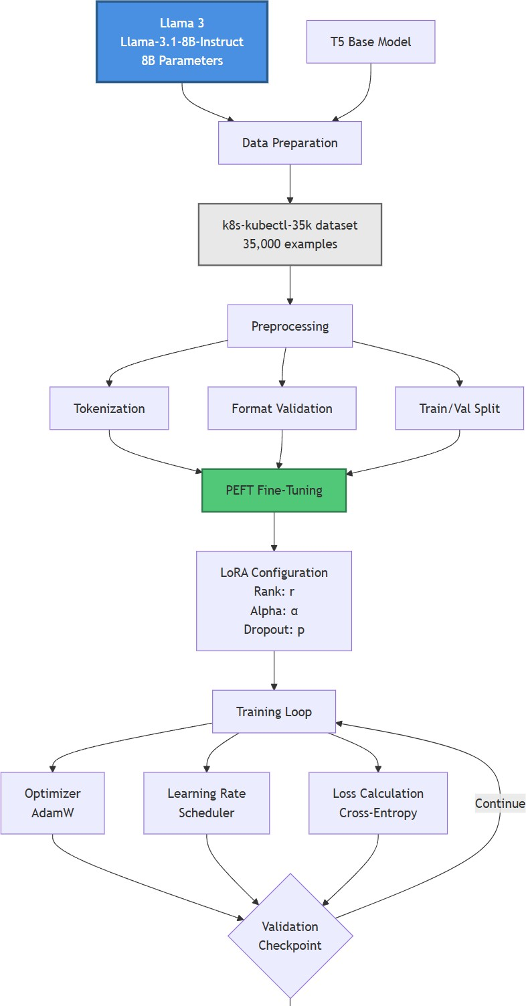

Figure 2: Framework of the project

115

120

125

130

135

140

145

* 1. *Fine-Tuning Pipeline for Llama-3.1-8B-Instruct on Kubernetes Commands*

# Initialize Environment

* + Import libraries (torch, transformers, datasets, sklearn, etc.)
  + Set device = "cuda"

# Load and Preprocess Data

* + Read CSV file containing (question, command) pairs

# Tokenization

* + Load tokenizer from base model (Llama-3.1-8B-Instruct)
  + Add special tokens if missing (e.g., padding)
  + Convert (question, command) into instruction-style prompt
  + Encode into input_ids and attention-mask

# Create Dataset Objects

* + Wrap encoded data into a PyTorch Dataset class
  + Implement getitem returning {input_ids, attention_mask, labels}
  + Prepare train_dataset and val_dataset

# Model Setup

* + Load base model (AutoModelForCausalLM)
  + Enable gradient checkpointing for memory efficiency
  + Assign model to device

# Define Training Arguments

* + output_dir = "./k8s-command-model"
  + num_train_epochs = 3
  + learning_rate = 2e-5
  + warmup_steps = 100
  + Use fp16 or bf16 for mixed precision
  + Perform evaluation and checkpoint saving every N steps

# Trainer Initialization

* + Pass model, training arguments, and datasets

# Training Loop

* + Trainer trains model for the specified epochs
  + Periodically evaluates on the validation set
  + Saves the best model checkpoint (lowest validation loss)

# Save Model & Tokenizer

150

155

* + Save final fine-tuned model
  + Save tokenizer to output_dir

# Inference Testing

* + Load trained model from checkpoint
  + For a sample input question, generate the corresponding kubectl command
  1. *Flow Diagram*

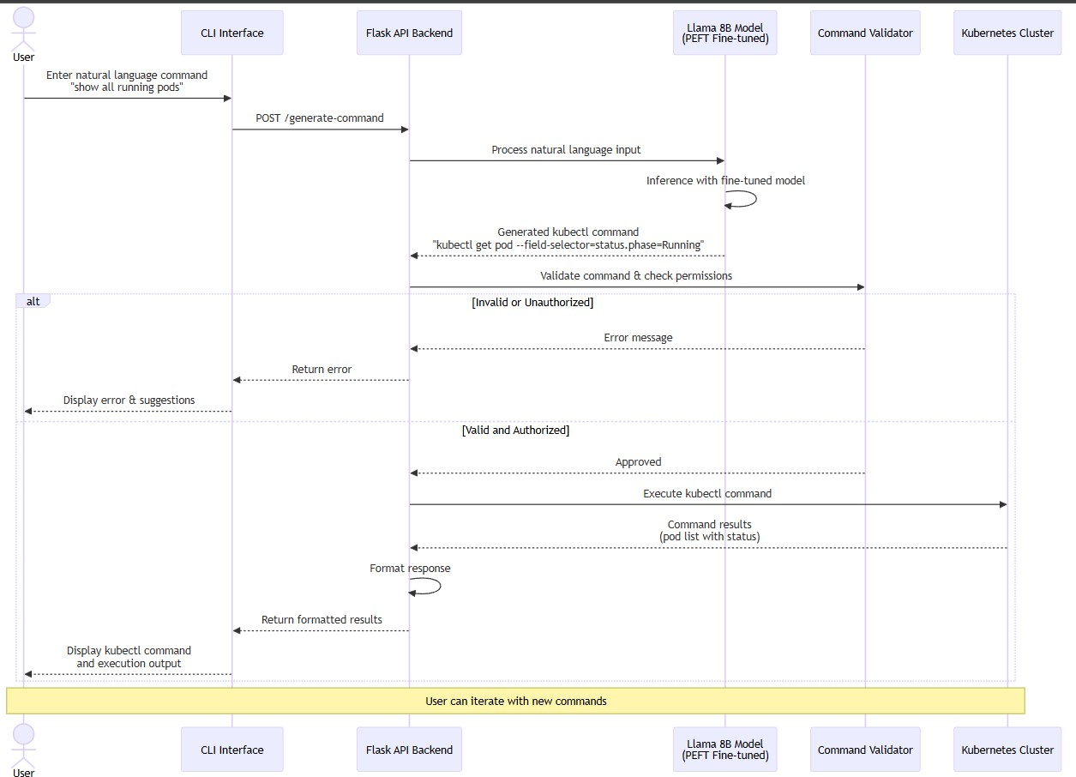

Figure 3: Framework of the project

# Experiments

* 1. *Dataset Description*

The dataset used for training and evaluation in this work is the **ComponentSoft/k8s- kubectl-35k** dataset, sourced from Hugging Face. It comprises approximately 35,000 pairs of natural language (NL) commands and their corresponding Kubernetes (kubectl) command-line interface (CLI) equivalents.

160

165

170

175

Each entry consists of:

* A natural language instruction, e.g., *“Create nginx deployment”*
* A target command, e.g., kubectl rollout restart deployment frontend

The dataset includes diverse categories of Kubernetes operations such as:

* **Pod management:** creating, deleting, listing, and describing pods.
* **Deployment operations:** rolling updates, scaling, and restarts.
* **Service configuration:** exposing, port-forwarding, and inspecting services.
* **Cluster and node management:** managing contexts, nodes, and namespaces. A subset sample of the dataset is shown below.

Table 2: Sample of the ComponentSoft/k8s-kubectl-35k Dataset

|  |  |  |
| --- | --- | --- |
| **ID** | **Natural Language Query** | **Target Kubernetes Command** |
| 001 | List all services in ps output for- | kubectl get services |
|  | mat |  |
| 002 | show all running pods in the de- | kubectl get pods |
|  | fault namespace | –namespace=default |
| 003 | delete the nginx pod | kubectl delete pod nginx |
| 004 | scale backend deployment to 3 | kubectl scale deployment backend |
|  | replicas | –replicas=3 |
| 005 | list all namespaces | kubectl get namespaces |

* 1. *Preprocessing and Data Cleaning*

Before fine-tuning the models, the dataset underwent the following preprocessing steps:

1. **Normalization of Text:** All queries were converted to lowercase, and punctuation inconsistencies (e.g., extra commas or dots) were removed.
2. **Tokenization Compatibility:** Special characters such as -, /, and – were pre- served to ensure accurate mapping to Kubernetes CLI syntax.
3. **Deduplication:** Duplicate entries and trivial command variants were filtered out to avoid overfitting.

180

185

190

195

200

* 1. *Model Configurations*
     1. *LLaMA-3.1-8B-Instruct*

The **LLaMA-3.1-8B-Instruct** model, known for its strong instruction-following ca- pability, was fine-tuned on the curated dataset using the LoRA (Low-Rank Adaptation) technique to reduce GPU memory usage.

* + - * Model Size: 8 billion parameters
      * Training Batch Size: 4
      * Learning Rate: 2e-5
      * Epochs: 3
      * Optimizer: AdamW
      * Training Platform: NVIDIA H100 GPU SXM (80 GB VRAM)
      * Precision: FP16 mixed precision
    1. *T5-Base*

The **T5-Base** model (220M parameters) was selected for its compact size and flexi- bility for local usage on devices with limited memory (around 1 GB VRAM).

* + - * Model Size: 220M parameters
      * Tokenizer: SentencePiece tokenizer
      * Learning Rate: 3e-5
      * Batch Size: 8
      * Epochs: 4
      * Framework: PyTorch with Hugging Face Transformers
      * Loss Function: Cross-entropy loss
  1. *Training Procedure*

The fine-tuning followed a supervised sequence-to-sequence paradigm:

* **Input:** Natural language query ( *“Get detailed information about the backend pod.”*)
* **Output:** Corresponding kubectl command (e.g., kubectl rollout restart deployment frontend)

205

210

* 1. *Evaluation Metrics*

The models were evaluated using the following quantitative metrics:

* **BLEU score** – measures n-gram overlap between predicted and reference com- mand.
* **ROUGE-L** – captures sequence-level similarity.
* **Exact Match (EM) accuracy** – fraction of perfectly matched commands.
* **Edit Distance (Levenshtein Distance)** – measures structural closeness.

# Results and Discussion

* 1. *Quantitative Results*

The overall comparison between **LLaMA-3.1-8B-Instruct** and **T5-Base** is shown in Table 3.

Table 3: Quantitative comparison between LLaMA-3.1-8B-Instruct and T5-Base

|  |  |  |  |  |  |
| --- | --- | --- | --- | --- | --- |
| **Model** | **BLEU** | **ROUGE-L** | **Exact Match (%)** | **Edit Distance** *↓* | **Size** |
| LLaMA-3.1-8B  T5-Base | 0.76  0.602 | 0.95  0.965 | 90%  85% | 1.0-2.0 tokens  2.0-3.5 tokens | 25 GB  800 MB |

215 **Observation:**

LLaMA-3.1-8B-Instruct achieved higher overall accuracy and fluency due to its larger parameter count and stronger contextual understanding, while T5-Base performed com- petitively despite its smaller size demonstrating high local deployability and inference efficiency for real-time Kubernetes assistance.

Metrics

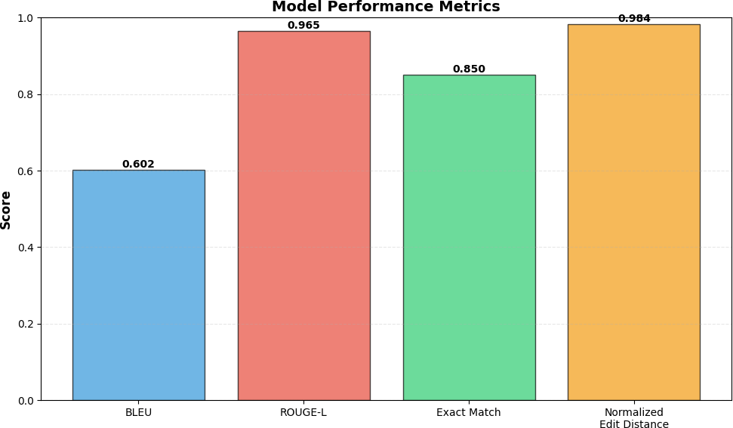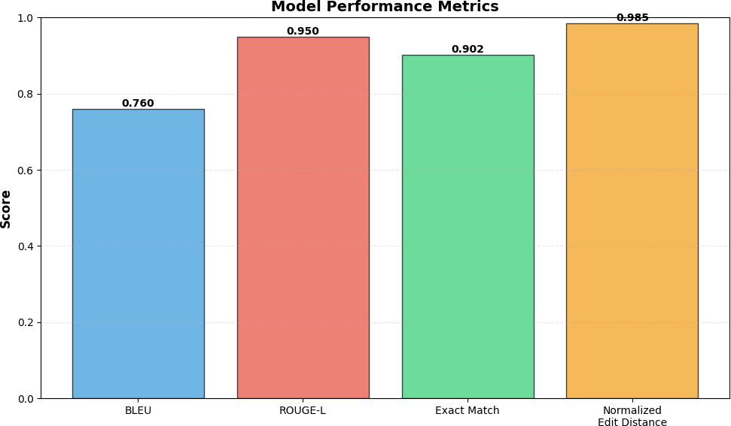

Figure 4: T5 Model Metrics Figure 5: Llama-3.1-8B-Instruct Model

220 *5.2. Visual Analysis*

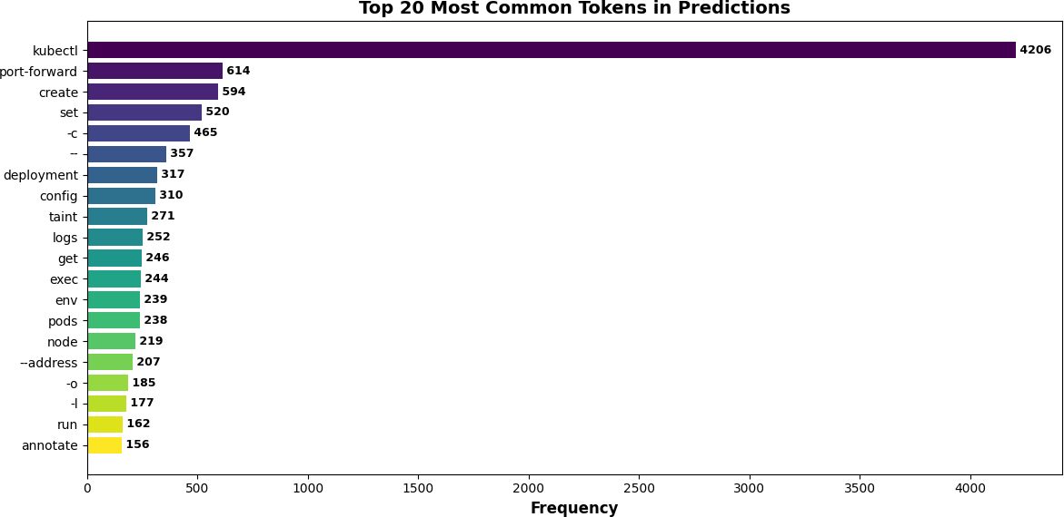

Figure 6: Top 20 Most Common Tokens in Prediction

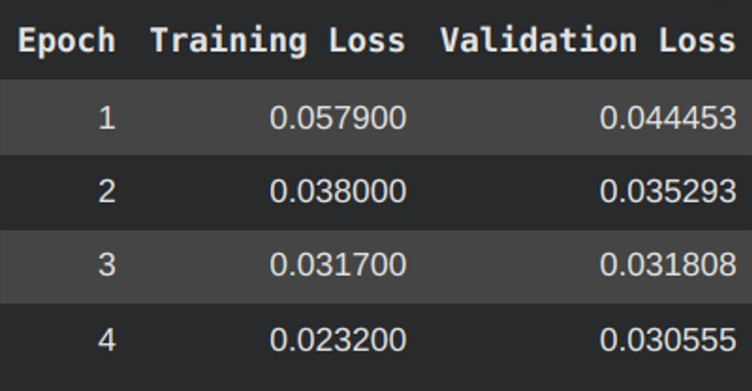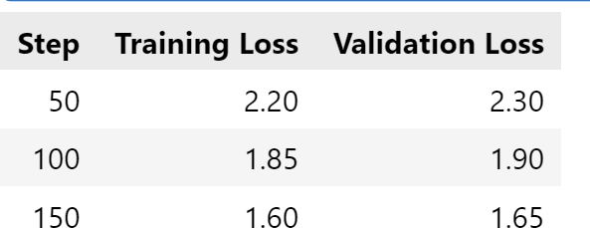

Figure 7: T5-Base Training Figure 8: Llama-3.1-8B-Instruct Training Loss

* 1. *Qualitative Observations*

A few example predictions from both models are summarized below.

# Analysis:

* + - LLaMA’s larger context window captured longer dependencies, producing highly

225 accurate commands with correct flags and namespaces.

* + - T5 sometimes missed CLI flags (e.g., –replicas, –namespace) but still produced syntactically close commands, making it suitable for edge or offline tools where full 8B model inference is impractical.

Table 4: Sample qualitative predictions from both models

|  |  |  |  |
| --- | --- | --- | --- |
| **Natural Language**  **Input** | **LLaMA-3.1-8B**  **Prediction** | **T5-Base Prediction** | **Reference Com-**  **mand** |
| restart frontend pod | kubectl rollout  restart deployment frontend | kubectl restart  pod frontend (minor syntax variation) | kubectl rollout  restart deployment frontend |
| show all pods in kube-  system | kubectl get pods  -n kube-system | kubectl get  pods –namespace kube-system | kubectl get pods  -n kube-system |
| scale backend to 5  replicas | kubectl scale  deployment backend –replicas=5 | kubectl scale  deploy backend 5 (incomplete flag) | kubectl scale  deployment backend –replicas=5 |

230

235

* 1. *Interface and Outputs*

The fine-tuned model was integrated into a web-based interface (built using an **Ex- press.js** backend and **React** frontend), where users can input natural language instruc- tions and receive the corresponding Kubernetes command output in real time.

* + - **Backend:** Handles model inference and API calls.
    - **Frontend:** Provides a user-friendly input box and command preview pane.
    - **Deployment:** AWS GPU Instance / Runpod GPU pods.

240

245

* 1. *Discussion*

The experiments confirm that large instruction-tuned models such as **LLaMA-3.1- 8B** can be successfully fine-tuned to serve as Kubernetes command assistants, enabling developers and DevOps engineers to operate clusters via natural language. However, due to the computational demand of LLaMA-3B, smaller models like **T5-Base** remain practical for on-premise or local setups.

# Key Takeaways:

* + - **LLaMA-3.1-8B** achieved superior command generation accuracy, especially for multi-flag commands.
    - **T5-Base** offers high portability and real-time inference speed suitable for lightweight integrations.
      * The **ComponentSoft/k8s-kubectl-35k** dataset effectively bridges the semantic gap between natural and operational languages.

# Conclusion and future scope

250

255

260

265

270

In this work, we explored the task of translating natural-language queries into kubectl commands using two pretrained language model architectures: the large instruction-tuned LLaMA-3.1-8B-Instruct and the more compact T5-Base (220 M parameters). We fine- tuned both models on the domain-specific dataset ComponentSoft/k8s-kubectl-35k com- prising approximately 35 k natural-language → kubectl pairs, and compared their perfor- mance across standard metrics. Our results demonstrate that LLaMA-3.1-8B achieved superior accuracy and command correctness in most categories, especially for complex queries involving flags, namespaces, and combined operations. Meanwhile, T5-Base de- livered competitive performance although lower absolute accuracy but offers a much smaller footprint, making it highly suitable for local on-premise deployment or resource- constrained environments.

Taken together, our findings suggest that fine-tuned instruction-models can effectively serve as Kubernetes CLI assistants, reducing the cognitive burden on DevOps practition- ers and enabling natural-language interfaces to cluster operations. Moreover, the use of smaller models like T5-Base illustrates a credible trade-off: slightly reduced accuracy in exchange for improved deployment feasibility in edge or offline contexts.

Potential future work includes incorporating reinforcement learning with human feed- back (RLHF) to further refine natural command alignment and integrating error correc- tion for invalid command generation.

# References

1. C. Ltd., k8s-kubectl-35k,

[https://huggingface.co/datasets/ComponentSoft/](https://huggingface.co/datasets/ComponentSoft/k8s-kubectl-35k)

[k8s-kubectl-35k](https://huggingface.co/datasets/ComponentSoft/k8s-kubectl-35k), accessed: 2025-08-08 (2025).

1. M. Chen, J. Tworek, H. Jun, Q. Yuan, H. P. D. O. Pinto, J. Kaplan, H. Edwards,

Y. Burda, N. Joseph, G. Brockman, et al., Evaluating large language models trained on code, arXiv preprint arXiv:2107.03374.

275

280

1. H. Touvron, T. Lavril, G. Izacard, X. Martinet, M.-A. Lachaux, T. Lacroix, B. Roz- ière, N. Goyal, E. Hambro, F. Azhar, et al., Llama: Open and efficient foundation language models, arXiv preprint arXiv:2302.13971.
2. C. Raffel, N. Shazeer, A. Roberts, K. Lee, S. Narang, M. Matena, Y. Zhou, W. Li,

P. J. Liu, Exploring the limits of transfer learning with a unified text-to-text trans- former, Journal of machine learning research 21 (140) (2020) 1–67.

1. Z. Feng, D. Guo, D. Tang, N. Duan, X. Feng, M. Gong, L. Shou, B. Qin, T. Liu,

D. Jiang, et al., Codebert: A pre-trained model for programming and natural lan- guages, arXiv preprint arXiv:2002.08155.

285

290

295

1. Y. Wang, W. Wang, S. Joty, S. C. Hoi, Codet5: Identifier-aware unified pre-trained encoder-decoder models for code understanding and generation, arXiv preprint arXiv:2109.00859.
2. X. V. Lin, C. Wang, L. Zettlemoyer, M. D. Ernst, Nl2bash: A corpus and semantic parser for natural language interface to the linux operating system, arXiv preprint arXiv:1802.08979.
3. A. Dubey, A. Jauhri, A. Pandey, A. Kadian, A. Al-Dahle, A. Letman, A. Mathur,

A. Schelten, A. Yang, A. Fan, et al., The llama 3 herd of models, arXiv e-prints (2024) arXiv–2407.

1. A. Angi, L. Nedoshivina, A. Sacco, S. Braghin, M. Purcell, A perspective on llm data generation with few-shot examples: from intent to kubernetes manifest, in: Proceed- ings of the 63rd Annual Meeting of the Association for Computational Linguistics (Volume 6: Industry Track), 2025, pp. 345–354.
2. Q. Fu, Z. Teng, J. White, D. C. Schmidt, A transformer-based approach for translat- ing natural language to bash commands, in: 2021 20th IEEE International Confer- ence on Machine Learning and Applications (ICMLA), IEEE, 2021, pp. 1245–1248.

300

305

1. Q. Fu, Z. Teng, M. Georgaklis, J. White, D. C. Schmidt, Nl2cmd: An up- dated workflow for natural language to bash commands translation, arXiv preprint arXiv:2302.07845.
2. S. Bharadwaj, S. Shevade, Explainable natural language to bash translation using abstract syntax tree, in: Proceedings of the 25th Conference on Computational Natural Language Learning, 2021, pp. 258–267.
3. Q. Fu, Z. Teng, J. White, D. C. Schmidt, A transformer-based approach for translat- ing natural language to bash commands, in: 2021 20th IEEE International Confer- ence on Machine Learning and Applications (ICMLA), IEEE, 2021, pp. 1245–1248.

310

315

1. Y. Wang, H. Le, A. D. Gotmare, N. D. Bui, J. Li, S. C. Hoi, Codet5+: open code large language models for code understanding and generation (2023), URL https://arxiv. org/abs/2305.07922.
2. J. Lin, K. Dzeparoska, A. Tizghadam, A. Leon-Garcia, Appleseed: Intent-based multi-domain infrastructure management via few-shot learning, in: 2023 IEEE 9th International Conference on Network Softwarization (NetSoft), IEEE, 2023, pp. 539– 544.
3. H. Touvron, L. Martin, K. Stone, P. Albert, A. Almahairi, Y. Babaei, N. Bashlykov,

S. Batra, P. Bhargava, S. Bhosale, et al., Llama 2: Open foundation and fine-tuned chat models, arXiv preprint arXiv:2307.09288.

320

325

1. B. Roziere, J. Gehring, F. Gloeckle, S. Sootla, I. Gat, X. E. Tan, Y. Adi, J. Liu,

R. Sauvestre, T. Remez, et al., Code llama: Open foundation models for code, arXiv preprint arXiv:2308.12950.

1. I. Jindal, C. Badrinath, P. Bharti, L. Vinay, S. D. Sharma, Balancing continuous pre-training and instruction fine-tuning: Optimizing instruction-following in llms, arXiv preprint arXiv:2410.10739.
2. T. Zhang, S. Pan, Z. Zhang, Z. Xing, X. Sun, Deployability-centric infrastructure-as- code generation: An llm-based iterative framework, arXiv preprint arXiv:2506.05623.
3. X. Garcia, Y. Bansal, C. Cherry, G. Foster, M. Krikun, M. Johnson, O. Firat, The unreasonable effectiveness of few-shot learning for machine translation, in: Interna- tional Conference on Machine Learning, PMLR, 2023, pp. 10867–10878.